**1).**

**import** java.io.BufferedReader;

**import** java.io.IOException;

**import** java.io.InputStreamReader;

**public** **class** Assignment6 {

**public** **static** **void** main(String args[]) **throws** IOException

{ String we="quiet";

**while**(**true**)

{

BufferedReader reader = **new** BufferedReader(**new** InputStreamReader(System.*in*));

System.*out*.println("Enter the numerator:");

String num="aa";

**int** q=0;

num=reader.readLine();

q= num.compareTo(we) ;

**if**(q==0){**break**;}

**int** numm =0;

**try**{

numm= Integer.*parseInt*(num);

}

**catch**(NumberFormatException e)

{

System.*out*.println(" you entered bad data \n please try again ");

**continue**;

}

System.*out*.println("Enter the Denominator:");

**int** T= Integer.*parseInt*(reader.readLine());

**int** ans=0;

**try**{

ans=numm/T;

}

**catch**(ArithmeticException e)

{

System.*out*.println("you can't divide "+numm+" by " +T);

}

**if**(T!=0){System.*out*.println(numm+" / "+T+" is "+ans);}

}

}

}

*************

**#OUTPUT**

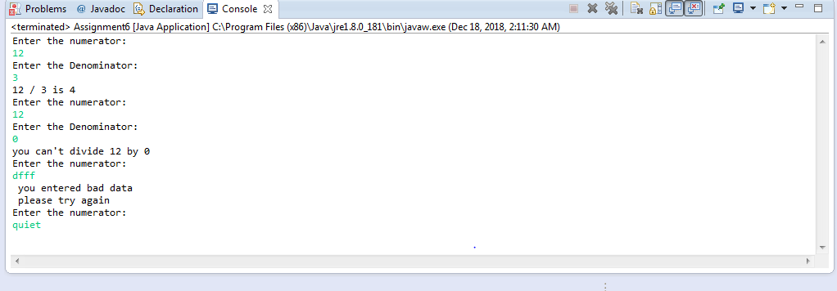

**2.1).**

package question.pkg2;

public class CallEg {

public void methodA() throws ArithmeticException

{

int k = 78/0;

}

public void methodB() throws ArithmeticException

{

}

public void methodC() throws ArithmeticException

{

}

}

public class TestTrace

{

public static void main(String[] args) {

CallEg eg = new CallEg();

try {

eg.methodA();

}

catch (ArithmeticException oops)

{

oops.printStackTrace();

}

}

}

**#OUTPUT**

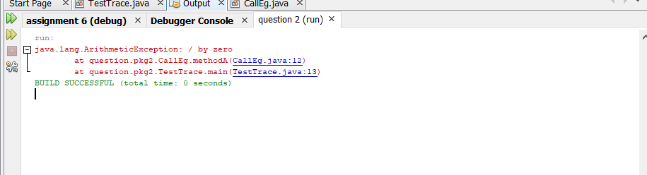

**2.2).**

package question.pkg2;

public class CallEg {

public void methodA() throws ArithmeticException

{methodB();

}

public void methodB() throws ArithmeticException

{methodC();

}

public void methodC() throws ArithmeticException

{

int k=5/0;

}

}

public class TestTrace

{

public static void main(String[] args) {

CallEg eg = new CallEg();

try {

eg.methodA();

}

catch (ArithmeticException oops)

{

oops.printStackTrace();

}

}

**#OUTPUT**

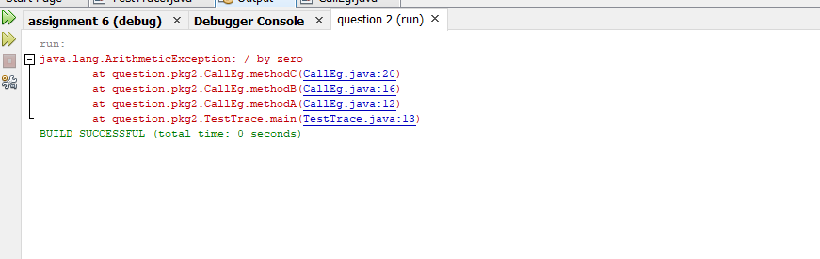

**2.3).**

package question.pkg2;

public class CallEg {

public void methodA() throws ArithmeticException

{

try { methodB();}

catch(ArithmeticException k){

k.printStackTrace();}

}

public void methodB() throws ArithmeticException

{

try { methodC();}

catch(ArithmeticException a)

{ a.printStackTrace();

}

}

public void methodC() throws ArithmeticException

{

try { int k =78/0;}

catch(ArithmeticException e){

e.printStackTrace();

}

}

}

public class TestTrace

{

public static void main(String[] args) {

CallEg eg = new CallEg();

try {

eg.methodA();

}

catch (ArithmeticException oops)

{

oops.printStackTrace();

}

}

**#OUTPUT**

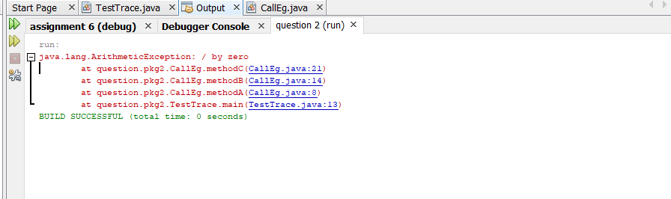

**3).**

package assignment.pkg6;

class Divider

{

public void methodA()

{

System.out.println("Result:"+12/4);

}

public void methodB()

{

System.out.println("Result:"+12/3);

}

public void methodC()

{

System.out.println("Result:"+12/0);

}

}

public class TestTrace

{

public static void main(String[] args) {

{

Divider dvdr = new Divider();

try {

dvdr.methodA();

dvdr.methodB();

dvdr.methodC();

}

catch (ArithmeticException oops){

oops.printStackTrace();

}

}

}

}

**#OUTPUT**

